[Kali安装VMware tools（详细+异常处理）](http://www.cnblogs.com/dunitian/p/4709210.html)

**dnt@MT:~$ cd /media/cdrom0** 进入光驱内

**dnt@MT:/media/cdrom0$ ls** 查看当前目录下有哪些内容  
manifest.txt run_upgrader.sh VMwareTools-9.6.2-1688356.tar.gz vmware-tools-upgrader-32 vmware-tools-upgrader-64

**dnt@MT:/media/cdrom0$ cp VMwareTools*.tar.gz /home**拷贝VWTools到home目录下（注意大小写）

**dnt@MT:/media/cdrom0$ cd**

**dnt@MT:~$ ls**  
Desktop dnt VMwareTools-9.6.2-1688356.tar.gz

**dnt@MT:~$ gzip -d VMwareTools*.tar.gz** 把.gz解压成tar（文件大小会变大）

**dnt@MT:~$ ls**  
Desktop dnt VMwareTools-9.6.2-1688356.tar

**dnt@MT:~$ tar -xvf VMwareTools*.tar** 解压文件并显示详细解压过程

**dnt@MT:~$ ls**  
Desktop dnt VMwareTools-9.6.2-1688356.tar vmware-tools-distrib

**dnt@MT:~$ cd vmware\***进入 vmware-tools-distrib 目录下

**dnt@MT:~/vmware-tools-distrib$ ls**  
bin doc etc FILES INSTALL installer lib vmware-install.pl

**dnt@MT:~/vmware-tools-distrib$ su**切换到root账号  
密码：

**root@MT:/home/dnt/vmware-tools-distrib# ./vmware*.pl  运行安装包（具体的如下图所示）**

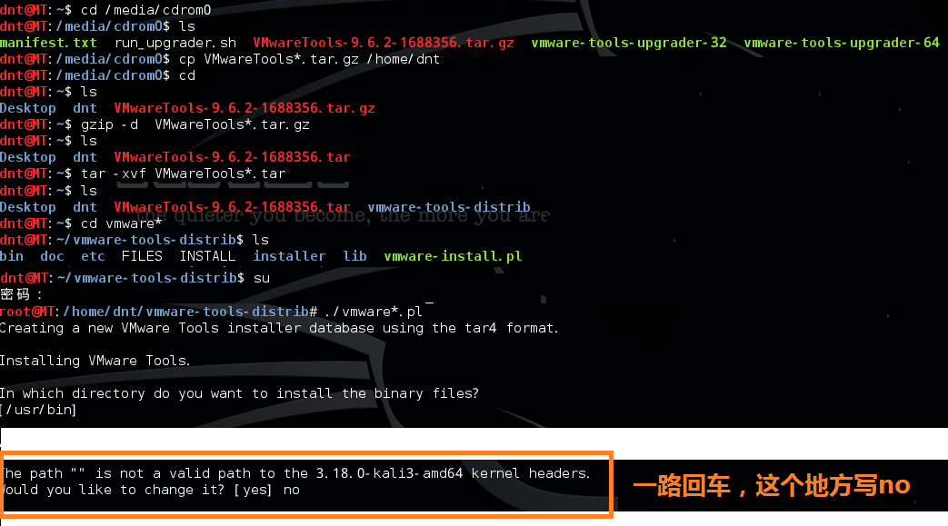

**root@MT:reboot  重启一下**

注意这个情况：

**root@MT:/home/dnt/vmware-tools-distrib# ./vmware*.pl**  
A previous installation of VMware Tools has been detected.

The previous installation was made by the tar installer (version 4).

Keeping the tar4 installer database format.

You have a version of VMware Tools installed. Continuing this install will   
first uninstall the currently installed version. Do you wish to continue?   
(yes/no) [yes]

Error: Unable to find the binary installation directory (answer BINDIR)  
in the installer database file "/etc/vmware-tools/locations".

Uninstall failed. Please correct the failure and re run the install.

Execution aborted.

**解决方法：**

**root@MT:/home/dnt/vmware-tools-distrib# rm -rf /etc/vmware-tools**  
**root@MT:/home/dnt/vmware-tools-distrib# rm -rf /tmp/vm\***  
**root@MT:/home/dnt/vmware-tools-distrib# ./vmware*.pl**

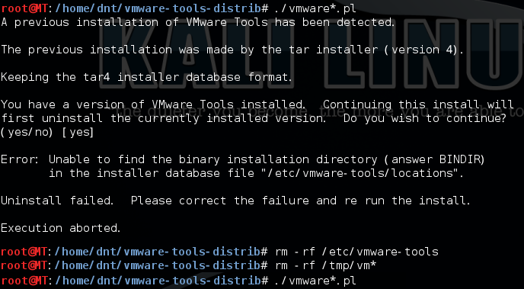

参考资料：  
http://blog.sina.com.cn/s/blog_4fd50c390101897e.html

http://kb.vmware.com/selfservice/search.do?cmd=displayKC&docType=kc&docTypeID=DT_KB_1_1&externalId=2101470